Atomic structure and Periodic chart pre-test review Name___________________
- Where can you find valence electrons?
- In the nucleus b. On the electron shells C. on the outermost energy level

- When calculating the mass of an atom you add the number of ______________ and the number of _______________. You do not include the number of ________________ .

- Most of an atoms mass is found in the (electron cloud or nucleus).

- The smallest (least mass) of the subatomic particles is the

  - Proton b. Neutron c. Electron

- The _____________ and _______________ are found in the nucleus of an atom. The ___________ orbit the nucleus of an atom.

- The amu (atomic mass unit) of a proton is _____________ of a neutron is _____________ of an electron is _______________.

- Which is the biggest of the subatomic particles?__________ Which is the smallest? _______

- Electrons on energy levels farthest from the nucleus have (more or less) energy.

- The proton has a ___________ charge, the neutron has a __________ charge and the electron has a ________________ charge.

- The element silver has a mass of 107. How many protons does it have? _________ How many neutrons?___________ How many electrons?____________

- To be neutral an element must have the same number of ________________ and __________ . (subatomic particles)

- Elements in the same groups have the same number of __________ ______________.

- Elements in the same period have the same number of _________________________ .

- Elements on the left side of the periodic chart are:

  - Metallic b. Non-metallic c. Metalloids d. Gases

- Elements in the same group have:
  - Same mass number b. Same number of protons C. same chemical properties

- The element _______________ had 33 protons and 41 neutrons.

- The element ____________ has 21 neutrons and 18 electrons

- What does Calcium, beryllium and radium have in common?

  - Same atomic number b. same number of orbitals c. same number of valence e⁻

- For an atom to have a negative charge, it will need to have more _________ than _________ .

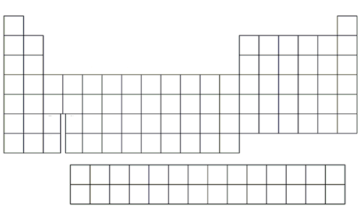
- Label the families on the periodic table on the left, color in the metalloids and label the metals and non-metals on the periodic table to the right.

- List 3 element that are found in the actinide series

- Which group of elements has 7 valence electrons?

- In group 1, which element has the largest atomic mass? ____________ which one has the smallest___________?

- Does carbon or oxygen have a smaller mass? _____________

- Which element has more protons? Zinc or gold

- In a family the element that has the smallest atomic number would be found at the top or at the bottom of the periodic chart?

- In a family the element that has the largest mass would be found at the top or at the bottom of the periodic chart?

- As you move from left to right in a period. The next element will (gain or lose) one ___________ and ____________.

- Which group on the periodic chart is the most reactive?_____________ least reactive?_____________

- Would (Magnesium or Krypton) have properties similar to Neon?

- Noble gasses are __________ and are found in group ______ on the (left or right) side of the periodic chart.

- An element with 6 electrons in its valence shell (or outermost energy level) would be found in group #________________

- All of the elements in group 2 are considered:

  - Metals b. non metals c. metalloids d. Halogens

- Valence electrons are used to ___________ with other atoms

- What group is Argon found in?

- ______________ (metals, nonmetals, metalloids or inert gasses) are malleable and conduct electricity.

- Name one halogen _____________

- Name one noble gas _____________

- The periodic chart is organized

  - Randomly b. by similarities c. and can be changed if needed

- Which part of the periodic chart will you find elements that have large masses?

- Isotopes have a different number of ________________ so their atomic ___________ will be more than the normal element.

- Although there is very little difference a __________ is bigger than a ___________ which is far bigger than _______________ (proton, neutron, an electron)

- The periodic chart is organized by atomic number. Knowing this you can say it is also organized by order of increasing _____________. (subatomic particle)

- Valance electrons are used for bonding. So how many electrons do group 3 elements have to use for bonding?

- Molecules that have more than one type of element are ____________ instead of symbol they are represented by a _____________.

- The first energy level (shell) of an atom will hold ____ electrons. The second shell will hold____ and the third will hold _____.

- Families are also called ____________ or ____________ .

- Draw and label the element Sulfur.

- include protons, electrons and neutrons
- Charges (positive, negative an neutral)
- Valence shell (highest energy level)
- How many valence electrons does it have to share in bonding?

Make sure you know where the families are in the periodic chart. You will be expected to know the names of them to answer some of the questions.
Make sure you know how to draw and label an atom.
Make sure you understand valence electrons and how to find them.
Remember the area outside of the nucleus can be called – electron shells, energy levels and orbitals. Only the outermost ring is called the valence shell or highest energy level.
Items in bold have not been discussed in depth in class, make sure you study them.
Make sure you ask questions during the review days if you don’t understand something.
Good Luck!

